FARU
1.0

User Manual

Version 1.0

Contact:
Ni logic Pvt. Ltd.
201/202, C-2, Saudamani Commercial Complex, Bhusari Colony, Paud Road,
Kothrud, Pune - 411 038
Telefax : +91-20-25286947/8

Revision History
Date | Version | Description | Author
26/05/2016 | 1.0 | User manual of FARU Data Logger | Vinay
Table of Contents
Preface 4
1 Introduction 5
1.1 Block Diagram 5
1.2 Features 6
1.3 Specifications 6
1.4 Applications 7
1.5 Supported Sensors 7
2 Let’s Record 8
3 Writing Config File 10
4 Connecting Inputs 12
4.1 Interfacing high voltage 12
4.2 Interfacing 4-20ma Current Loop 12
5 Plotting Results 13
6 FAQs 16

Preface

About Document
This document contains the information regarding FARU-1.0 and its mode of use.
The document covers the most aspects for hardware design, and a framework for the usage part.

For further details and queries contact:
Ni logic Pvt. Ltd. (ni2designs)
201/202, C-2, Saudamani Commercial Complex,
Bhusari Colony, Paud Road,
Kothrud, Pune-411 038
Email : info@ni2designs.com
URL : www.ni2designs.com
Telefax : +91-20-25286947/8

Introduction

Field Analog Recorder Unit (FARU) is an analog data logger in compact form factor. It stores the analog signals in simple CSV (Comma Separated Values) format on a SD card. You can use simple software like Microsoft Excel or Libre, etc to plot the results. User are allowed to control the configuration like channels to log, sampling rate etc with simple interface.
What make FARU special is, it supports sampling frequencies from 200 micro seconds to several minutes, which makes it versatile to work in various applications. The device has dual color LED indications which helps user to identify the process status.

Block Diagram

FARU
SD Card
Analog signals

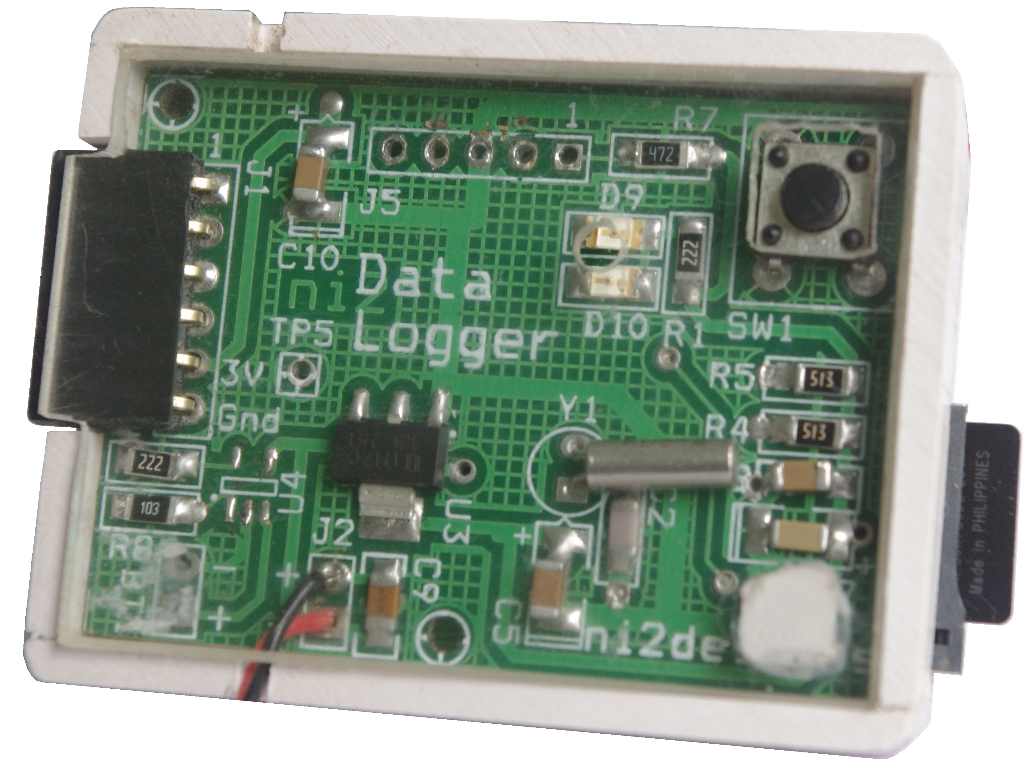
Input Channels
Start/Stop
switch
SD Card slot
LEDs
Power input
System Description

Features
Here are the highlighted features of FARU;
- Ultra-portable and small in size
- Four analog inputs, 0 ~ 3.3V range
- Support wide variety of analog sensor inputs
- Wide sampling ranges, from micro-seconds to minutes
- Simple to use and low cost
- LED indications
- Trigger support
- Sleep mode for power saving
- Writes the data in CSV format, which can imported in various software or simple excel programs.

Specifications
- Four input channels with each 12 bits of resolution.
- Input voltage range, 0 ~ 3.3 V
- Sampling range between 200 microseconds to several minutes
- Maximum sampling rate can applied to all 4 channels is 500us and for single channel user can squeeze upto 200us
- Dual LED for various status indications
- Automatic trigger controlled to start sampling when trigger level arrives
- Easy to write configuration using text file
- Switch for start and stop of operation
- Use of RTCC for time stamping
- Sleep mode for power saving
- Values stored directly in millivolts
- The sample values are automatically converted into millivolt to save manual conversion time
- Writes the data in .CSV format, which can imported in various software or simple excel programs.
- Very simple to use and low cost

Applications
FARU can support variety of applications and proves handy to work in field areas or where less human intervention is required.
Here are some of the applications and purpose for which FARU can be used.

Test and Measurement
Uptime monitoring of analogue signals from sensors/transducers. Reducing on-board voltage of a racing car, helicopter or field instruments.

Weather Monitoring
Monitoring outside temperature/humidity or green house sensors like soil moisture, condensation etc.

Education
Students can make use of FARU for understanding sensor operation in real field scenario or use it for understanding data logging applications, or even use it for project development purpose.

Supported Sensors
Most of the sensors whose voltage range in between 0 ~ 3.3V (with bandwidth of 0 ~ 1 Khz) can be connected to FARU.
Some sensors tested with FARU are,
1. Accelerometer
2. Piezo Electric Sensor
3. Temperature Sensor
4. Pressure Sensor

Let’s Record
The following session introduce the experimental set up and procedure for normal data logging process with Field Analog Recorder Unit (FARU).
This experiment shows the step by step procedure to record accelerometer output on 3 channels for X, Y and Z axis.

Step 1 : Setup the configuration file.
Write below data in the configuration text file and save as “config.txt”
The right hand side box, explains the config file for every line.
1 1 Channel 1 enabled
2 1 Channel 2 enabled
3 1 Channel 3 enabled
4 0 Channel 4 Disabled
500 u Sampling rate 500 us
60 s Recording period 60 seconds
80 No. of pre-sample for trigger
500 Trigger threshold level in mv
10 File name, printed as 10Hz
22/05/2015,12:30:00S Date/time
1 1
2 1
3 1
4 0
500 u
60 s
80
500
10
22/05/2015,12:30:00S

Explanation

Step 2 : Write this config file into a SD card and insert into FARU
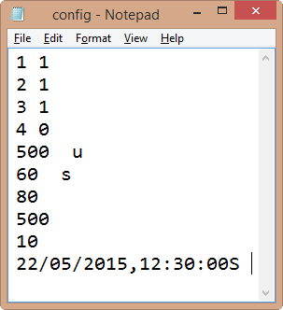

Pin | Signal
1 | Channel 1
2 | Channel 2
3 | Channel 3
4 | Channel 4
5 | VDD = 3.3V
6 | Ground
Step 3 : Connect accelerometer to the input header.
Input Channels
Ch1 on top

Step 4 : Press the ‘START’ button
The LED should go RED and data logger will wait for trigger.
When the trigger level arrives, the green LED will glow and will remain on till the data logging is in process.
When the green LED is off, that indicates the end of recording and you can remove SD and plot the data.
You can terminate process by manually by switching the switch.

Step 5 : Plot the data
Now plot the recorded data using Excel charts or any other software you like.
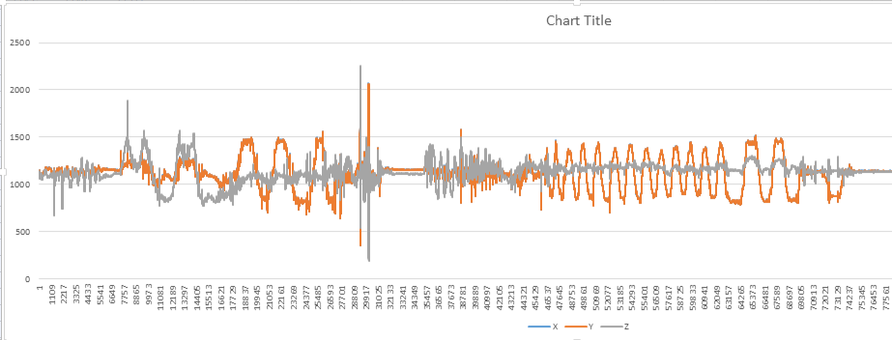

Known Errors:
If red LED is blinking, there is something wrong with SD card or configuration text. Please make sure that everything is fine.
If green LED does not glows, that means either trigger threshold is not coming or loose connection or trigger level not set properly.

Writing Config File
This section gives a descriptive understanding of configuration files, and its writing format.
You can use any text editor to make a configuration file, recommended is notepad as its available everywhere.
Every line in configuration file is meant to control something. The below table explains the format of file for every line.
Line No: | Data Format | Explanation
1 | 1<space>1 | 1 or 0 will enable or disable the channel.  <Space> means the space character.  Channel 1 enabled for sampling
2 | 2<space>0 | Channel 2 disabled
3 | 3<space>0 | Channel 3 disabled
4 | 4<space>1 | Channel 4 enabled
5 | 500<space><space>u | Sampling rate of 500 us  Small character ‘u’ is for micro seconds  Small character ‘m’ is for milli seconds  Small character ‘s’ is for seconds
6 | 10<space><space>s | Total recording period, here its 10 seconds  Supports only seconds and hours  Small character ‘h’ is for hour
7 | 40 | Number of pre samples before trigger. Max number pre-samples supported 60
8 | 1200 | Threshold voltage in millivolts. No need to specify unit
9 | 200 | Output file name now become 200Hz.csv  File name supports only numbers
10 | 22/03/2014,12:45:00S | Date and Time, should end with capital ‘S’

The below text box shows an example format for configuration file.
1 1
2 1
3 1
4 0
500 u
60 s
80
500
10
22/05/2015,12:30:00S

Trigger Enabled Sampling
In normal sampling, you can put number of pre samples and threshold voltage as zero. The FARU logger will start storing samples after you pressing the switch. But in trigger enable sampling, you have to provide the threshold voltage and number of pre samples required. Channel 1 is used as trigger input. The threshold voltage should provide as millivolt. These are the maximum number of pre samples you can apply for various sampling rates.
Sampling rate | Maximum no. of pre-samples
200 us | 40
500 us | 60
>1 ms | 80
Note: Only channel 1 can be used for trigger input. It will also record channel 1 after trigger

Analog Channels and Sampling rate
There are 4 channels which can be used for logging analog signals. The logger can be configured to use single or multiple channels. The maximum input voltage can applied is 3.3V. The sampling frequency will be commonly applied to all channels. All 4 channels have same sampling frequency applied. Maximum sampling rate can be applied for all 4 channels enabled is 500 us. But for single channel the maximum sampling rate can be applied as 200 us.
Recording Period
The recording time can mentioned in the configuration text. To avoid complexity only 2 different time can applied, second and hour. For second use character ‘s’ and for hour ‘h’. The recording will expire after the given time. But user can manually terminate the processing by pressing switch. The green LED turns off to indicate end of recording.

Connecting Inputs
There are 4 analog channels can be used for sampling purpose. Any sensor whose voltage range between 0 to 3V can be connected. There is a 3.3V volt input supply provided to provide power for sensor. The input header is shown below….

Pin | Signal
1 | Channel 1
2 | Channel 2
3 | Channel 3
4 | Channel 4
5 | VDD = 3.3V
6 | Ground

Interfacing high voltage
If you wish to record high voltage (like 0 ~ 10V) analog signals, then make a simple resistive voltage divider to bring the signal in a range of 0 ~ 3 V.
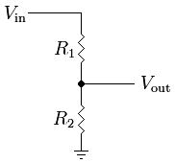The formula to calculate the output voltage is:
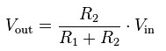
Note: Make sure to check voltage division using multimeter, before connecting to unit.

Interfacing 4-20ma Current Loop
Many industrial sensors (like pressure sensors, gas detectors, temperature sensors) gives output in current range of 4 ~ 20 ma. A signal lower than 4mA, typically indicates an error.
The 4-20mA current can be converted into voltage range of 0.6V to 3V by adding a 150R ohms 1% MFR type resistor in parallel to input. When the current is 4mA the board will read analog voltage as 0.6V, When the current is 20mA the board will read 3V

FARU

Sensor

150E

GND

CH1
Connect a 150 ohm resistor in parallel to Current loop
The calculation as per ohm low is as under for minimum, maximum of current range.
Current is 4mA = 0.004 x 150 = 0.6V (Voltage output)
Current is 20mA = 0.02 x 150 = 3V (Voltage output)

Plotting Results
This section explains how plots can be made from logged data.
Using MS-Excel
MS Excel is a useful platform to represent data in charts and graph. The data samples can be represent in graph format by following steps.
The result in .csv format will look like following,
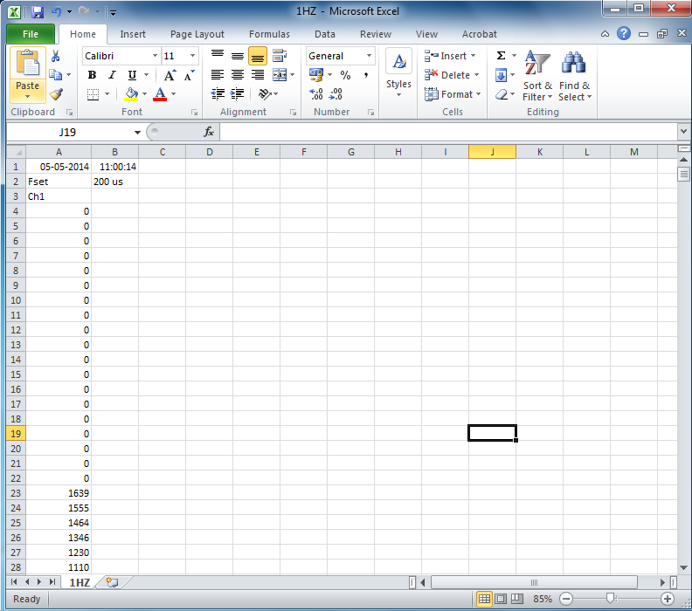
Select the data to be plotted, then go to insert, select line chart, the result will plot like this,
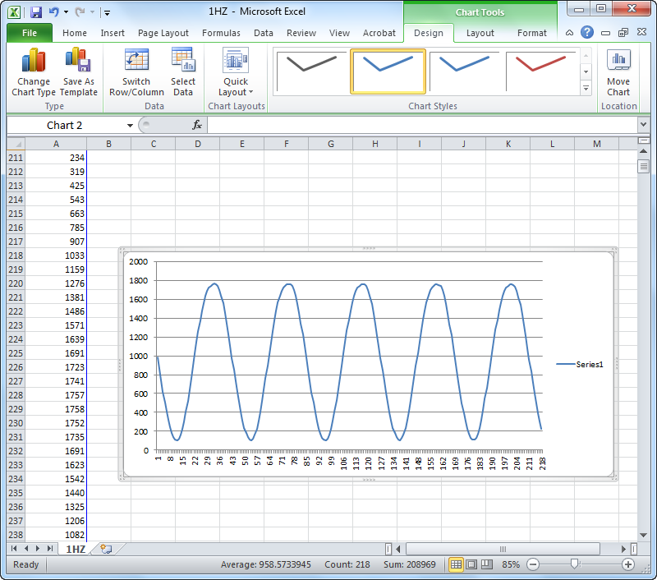

Using 20-Sim
20-Sim is simulation and analysis package for various applications. The software can be downloaded from www.20sim.com . It offers simple model making to read data from file. The file data can be plotted in simulator, and can be analyzed for various mathematical calculations like, FFT, mean, max, frequency, etc.
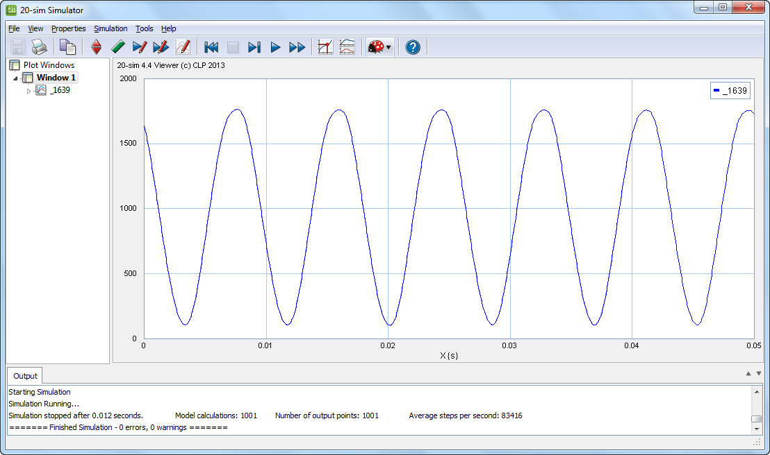

Using Matlab
Matlab is well known software for various mathematical and engineering applications. You can use Matlab to plot the file data and analyze for various mathematical reasons.
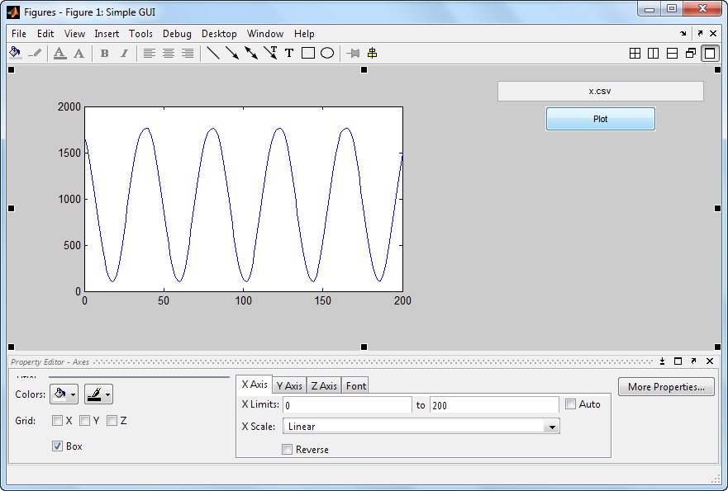
Changing X scale to time scale
The data logger do not writes the time scale in data file, as every sampled value is logged after specified sampling interval. Hence a time scale can be inserted manually. Lets say the sampling rate was 200us.
In excel insert a new column on ‘A’. Write ‘0’ for sampled value, which is cell ‘A2’. Then use this formula from cell A3.
A3 = A2 + 200e-6
A4 = A3 + 200e-6
Continue the formula till the end of sampled values.
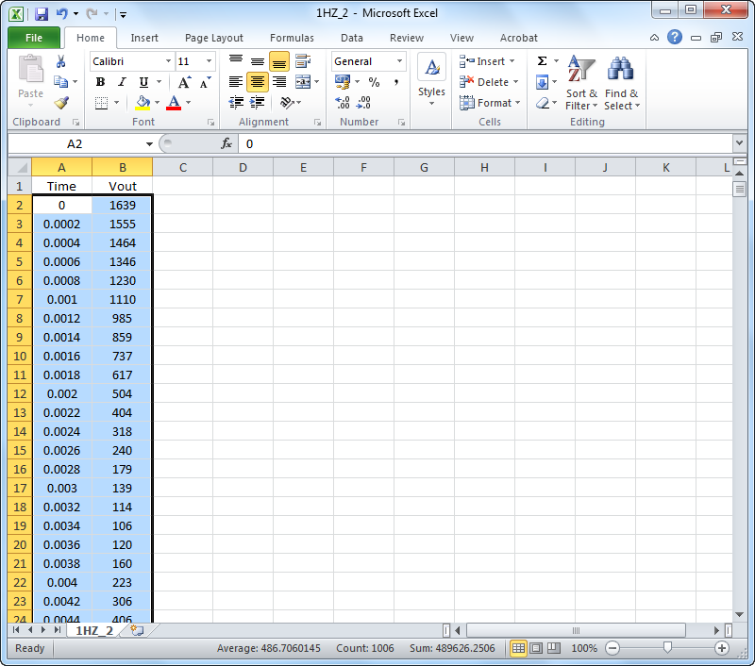
The plotting with time scale and voltage will now look like below.
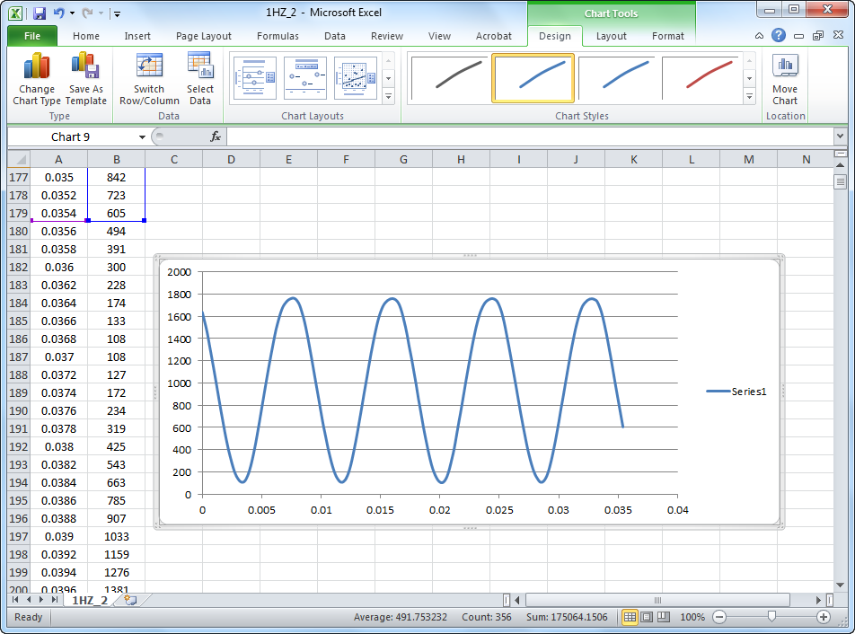

FAQs
Here are some frequently asked questions; although we are sure you may have many more questions which you can send at info@ni2designs.com

- What kind of inputs I can connect?
Ans: Well, any input with input voltage range of 0~3V and bandwidth as per sampling rate.
- Can I power my sensor from FARU?
Ans: Yes, power pins are provided at header and you can power your sensor circuits with +3.3V/0.2A
- My input voltage range is 0~10v, can I connect with FARU?
Ans: Yes, but you have to use resistor divider with division factor of atleast 3 or 4.
- What kind of SD card it supports, does it support SDHC and SD format?
Ans: It supports both SD and SDHC format.
- Do I need to format SD card in FAT or NTFS file format?
Ans: Format with FAT or FAT32 format.
- What is maximum size of SD card it supports?
Ans: Any card with FAT format support. We tested up to 16GB.
- What will happen if I remove SD card during the process?
Ans: Your data will lost and you need to restart the process.
- Does it require to format card before the process?
Ans: Usually not. If it fails, format and try again.
- What will happen if battery power fails..? Will my data lose?
Ans: Data will be lost, if the power fails before the process is completed and if sampling rate is in micro-seconds.
If sampling rate is more than 1ms then data will be recorded on every sample and will be not lose in case of power failure.
- What are the power requirements of this FARU?
Ans: Works with input voltage 3.8 – 15V and >300mA current. You can connect with any standard 9V battery or power adapter.
- How often should I replace the battery?
Ans: It depends on the battery. Common 9V battery works for few hours with maximum sampling rate.
- Can I configure the text file with some software?
Ans: Well using a simple notepad in windows is good enough.
- Can I use text file created using my MAC PC?
Ans: Yes, you can.
- How can I run the device for 15 minutes?
Ans: Simple, convert minutes into seconds. 15*60 equals 900 seconds.
- I can't view more than 1000000 samples using excel. Which software can I use to open large amount of data?
Ans: You can view using Notepad++ or text pad; or professional software like 20-sim or Matlab.
- What is the maximum sampling rate of this datalogger?
Ans: 200 us for single channel and 500 us for multichannel sampling.
- How long the FARU can log data?
Ans: As such we did not faced any problems, it will record as long as memory capacity of SD card, sampling rate and power is available.
- Can I pause the data logging process?
Ans: No, you can only stop data logging process.
- Will I lose my data if I press the switch, when the FARU is in sleep mode?
Ans: No, it will start new logging and the data will be saved in new file. You can retrieve the old data in previous recorded file. This is why we use numbers for file name.
- How do I know that my FARU is working?
Ans: Check the LED sequence. GREEN LED acts as power indicator in the beginning. After pressing switch RED LED will glow. After trigger GREEN LED will glow. Both LEDs are OFF when the device is in sleep mode. If an error occurs, any one of the LEDs will blink. Refer datasheet for error conditions.
- Red Led in my FARU is blinking. What might be the reason?
Ans: There are two reasons for that. You haven’t inserted SD card properly. Your SD card is faulty.
- Whom should I contact if my FARU is not working properly?
Ans: You can contact the manufacturer, Ni Logic Pvt Ltd. info@ni2designs.com

Limited Warranty
ni2designs (ni logic Pvt. Ltd. ) warrants that the Product, in the course of its normal use, will be free from defects in material and workmanship for a period of one (1) year and will conform to ni2designs specification therefore. This limited warranty shall commence on the date appearing on your purchase receipt.
ni2designs shall have no liability for any Product returned if ni2designs determines that the asserted defect a) is not present, b) cannot reasonably be rectified because of damage occurring before ni2designs receives the Product, or c) is attributable to misuse, improper installation, alteration, accident or mishandling while in your possession. Subject to the limitations specified above, your sole and exclusive warranty shall be, during the period of warranty specified above and at ni2designs option, the repair or replacement of the product. The foregoing warranty of ni2designs shall extend to repaired or replaced Products for the balance of the applicable period of the original warranty or thirty (30) days from the date of shipment of a repaired or replaced Product, whichever is longer.
THE FOREGOING LIMITED WARRANTY IS NI2DESIGNS’S SOLE WARRANTY AND IS APPLICABLE ONLY TO PRODUCTS SOLD AS NEW. THE REMEDIES PROVIDED HEREIN ARE IN LIEU OF a) ANY AND ALL OTHER REMEDIES AND WARRANTIES, WHETHER EXPRESSED OR IMPLIED OR STATUTORY, INCLUDING BUT NOT LIMITED TO, ANY IMPLIED WARRANTY OF MERCHANTABILITY OR FITNESS FOR A PARTICULAR PURPOSE, AND b) ANY AND ALL OBLIGATIONS AND LIABILITIES OF NI2DESIGNS FOR DAMAGES INCLUDING, BUT NOT LIMITED TO ACCIDENTAL, CONSEQUENTIAL, OR SPECIAL DAMAGES, OR ANY FINANCIAL LOSS, LOST PROFITS OR EXPENSES, OR LOST DATA ARISING OUT OF OR IN CONNECTION WITH THE PURCHASE, USE OR PERFORMANCE OF THE PRODUCT, EVEN IF NI2DESIGNS HAS BEEN ADVISED OF THE POSSIBILITY OF SUCH DAMAGES.
ni logic pvt. Ltd., Pune takes the liability to replace the module/product for any design fault from our side.
This user manual is for supporting designers to develop their application. All configuration, usage, design examples, pin assignments are provided to help it’s users. ni logic pvt. Ltd., Pune does not take any responsibility for typological errors, misprints, and damages caused with this manual.
ni logic pvt. Ltd., Pune does not take any responsibility of failures or damages caused to product due to incorrect design practices, misuse, improper handling or not following the datasheet specifications of devices.

